Module 5 - PHP Object Oriented Programming Step 04

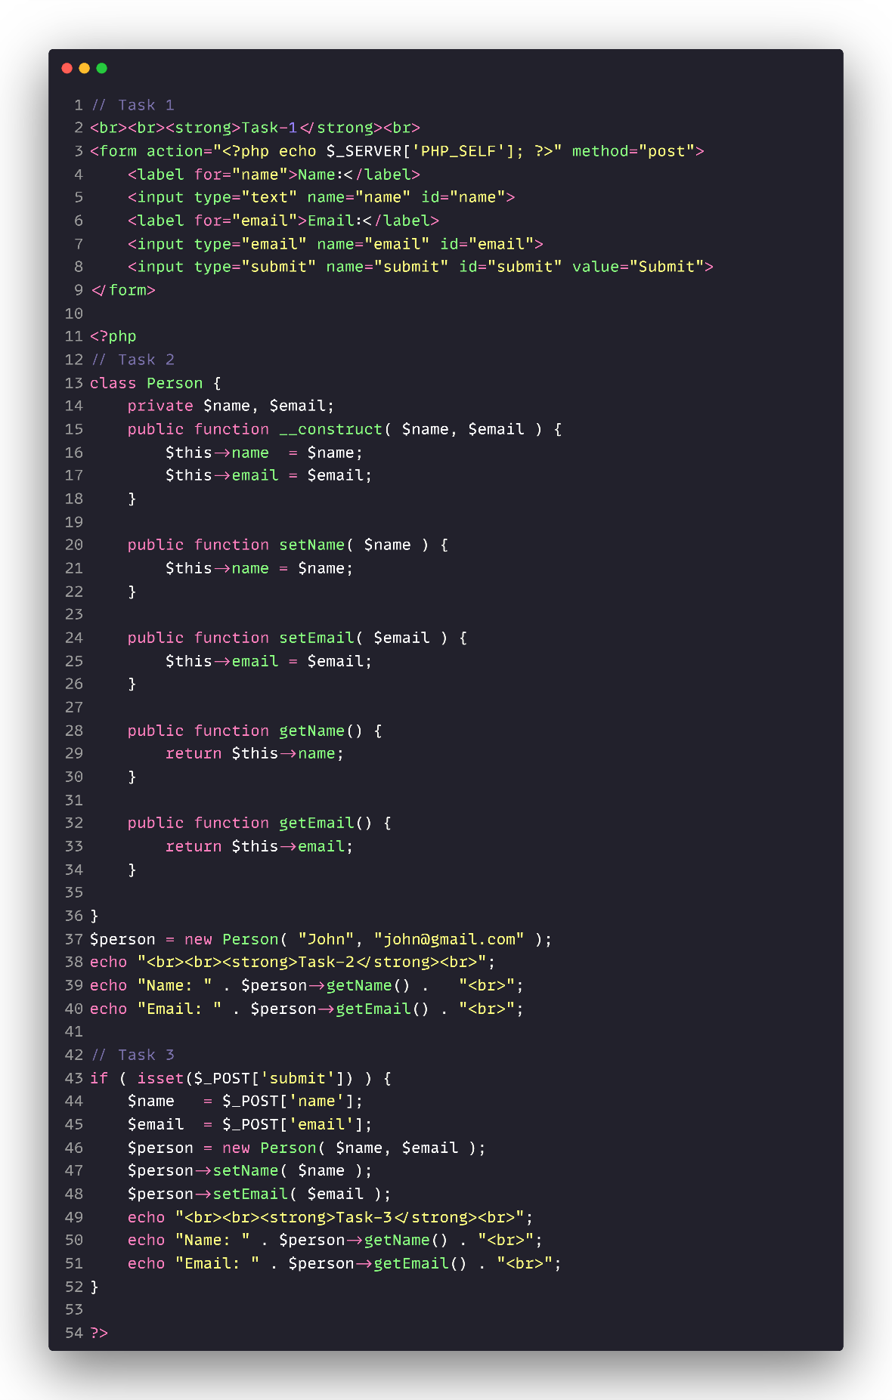

**Task-1**

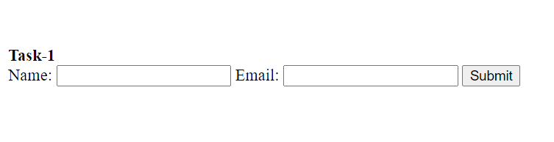

**Task-2**

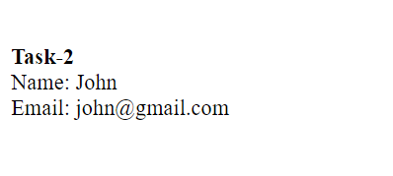

**Task-3**

